Experiment 8: K-means Algorithm

Aim
To implement K-means clustering algorithm.

Procedure
1. Initialize k centroids.
2. Assign points to the nearest centroid.
3. Update centroids based on mean of points.
4. Repeat until convergence.

Code
from sklearn.cluster import KMeans
import numpy as np
X = np.array([[1,2],[1,4],[1,0],
[10,2],[10,4],[10,0]])
kmeans = KMeans(n_clusters=2)
kmeans.fit(X)
print("Centroids:", kmeans.cluster_centers_)
print("Labels:", kmeans.labels_)

Output
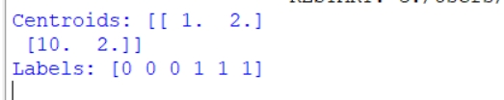

RESULT
K- means Clustering algorithm is implemented

